Scenario 2: Multi-trauma

Scenario:  Unstable trauma patient with pelvic and humeral fractures. Tension pneumothorax and falls in the elderly | Patient:  Mohammed Ali  72 year old man | Simulator  SIMMAN essential
Case Summary:  Mohammed Ali, 72 year old man. Fall from ladder, 3 m high, whilst cleaning the gutters.  PMHx - IHD, HT, DM, High-cholesterol.  Last used his GTN spray this morning.  His fall was unwitnessed, with ?LOC. He has a bruise on the left side of his head, his right upper arm is bruised and swollen, and he complains of all over body pain especially the right side.  He has a right sided pneumothorax, which will tension during the scenario and a lateral compression fracture of the pelvis, his proximal humerus is also fractured In the meantime they will resuscitate Mohammed with warmed fluids and blood products.  The pelvic XR will reveal a lateral compression fracture and likely source of bleeding. Ortho consultation and transfer to OT or angiography for definitive management |  | Participant Briefing:  BAT call  72yr male fall from a ladder  GCS 15  HR 100  BP 120/78  RR 24  sats 95%  ETA 2 minutes  On arrival paramedic gives the handover  I –Mohammed is a 72 year-old man, fell off a ladder  M - He fell from a ladder approx 3 m, whilst cleaning the gutters. He is unsure how he fell. He has pain in the right side of his body.  I - He has a graze on his head, bruising to the right side of his chest, hip, right arm and complaining of pain everywhere  S - HR 100, BP 120/78, GCS 15 but distressed, sats 95% on air, RR 24  T - 7.5mg of morphine iv, 10mg of metoclopramide. Not collared as he is non compliant.  A - NKDA  M – Ramipril and GTN spray  B - Hypertension and angina  O - Wife is on her way with the daughter and the son in law:
Clinical Issues |  | Human factors / Non technical issues
AcBCDE approach  Management of pelvic injuries  Condition, Cause, Complications and Co-Morbidities in trauma. |  | Any of the 7 Non-Technical Team Tasks
Learning Objectives:
Demonstrate a systematic AcBCDE approach with summaries and re evaluation of situation
Apply 7 Non-Technical Tasks. Perform a decompression/thoracostomy.
Consider the causes of hypotension in a trauma patient, acknowledge the use of pelvic splint in pelvic lateral compression fractures
Demonstrate situational awareness and open minded thinking in terms of other factors relevant to the circumstances of the fall
Communicate with the patient and team effectively
Faculty Actors: Faculty nurse who is proactive and helpful, patient
Mohammed Ali initially alert complaining of pain everywhere, then deteriorates as tension develops, continues to be hypotensive due to pelvic bleeding
Patient Moulage:
Bruise to right chest, graze on head, bruise to right hip and shoulder. beard

Equipment & Props:
EdWISE Trauma Box and Extras
• Local clinical documentation – resus charts, observation charts etc
Chest decompression equipment - cannulae, chest tubes, bottles/underwater seal, scalpel, forceps, sutures, 3 way tap.
Monitor: ED setup  ECG  SPO2  CO2 ready  NIBP | Investigations:  C-spine X-ray - Normal  X-ray chest - right rib fractures  X-ray pelvis - lateral compression fracture  XR humerus - fractured proximal humerus  ECG - Sinus tachycardia with ST depression in lateral leads  FAST image - normal |  | Response by team on receiving BAT call  Staff – allocate roles, PPE  Patient  Equipment – Airway equipment, C spine collars, pelvic binders, Fluid warmers and IV lines primed, blood products  Non-Invasive Monitoring  Drugs – labelled  Trauma Team called.
Patient presentation | Expected response by participants |  | Faculty /Actors Notes
BAT CALL  72yr male fall from a ladder  GCS 15  HR 100  BP 120/78  RR 24  sats 95%  ETA 2 minutes | Preparation and Planning |  | Give on 2 minutes to perform this.  Faculty Nurse – Helpful and prompting if required.
Initial Presentation  Rhythm sinus tachycardia  HR 100  BP 120/78  RR 24  SPO2 93%  Temp 35.8  GCS 15 | Takes handover from paramedics  AcBCDE approach  BSL 6.2 |  | Faculty Nurse  Gives handover and unveils Mohammed for the team.  Mohammed Ali  An elderly man complaining of pain and anxious. Needs prompting to be compliant with collar, Shouts out in pain when right side of chest, arm and pelvis are palpated. Pain on any movement.
Progression  After log roll, Mohammed becomes very anxious and severely distressed complaining of severe chest pain, he begins to deteriorate clinically  Sats - 89% on oxygen  RR - 28/min, reduced on the right  BP - 112/78 to 70/38  HR - 124/min SR  Temperature - 36.5 degrees | TL recognises this and starts again from an AcBCDE approach  Decompression of tension pneumothorax  If E-FAST performed there is no lung sliding. |  | Faculty Nurse  Prompt the team to recognize the deterioration in Mohammed and to reassess. Let them know that he is in much more pain now and vitals changing. need to mention out loud that there is a loud hiss of air once they decompress the chest  Mohammed Ali  Mohammed is becomes acutely more distressed with severe chest pain and dyspnoea. becomes distressed and complains of intense chest pain
Deterioration  Sats - 97% on oxygen  RR - 20/min  BP - 95/68  HR - 122/min SR  Temperature - 36.5 degrees | Following decompression of tension and insertion of ICC, TL recaps from an AcBCDE approach  Considers the other causes of hypotension and asks for FAST which will be negative. Team considers may be bleeding in either the chest, abdo, pelvis or long bones |  | Faculty Nurse  Helpful and proactive  Mohammed Ali  Mohammed is much less distressed as chest pain subsiding. Will start to ask about his wife. Remains GCS 15 and will complain about his hip if moved/log rolled.
Debrief Guide
Key clinical issues  (Select 2 clinical topics to debrief *=suggested)  Structured approach to the trauma patient  Approach to the deteriorating patient  ICC insertion and when appropriate to perform it  Host site specific management of pelvic fracture stabilization and management |  | Key non technical issues  Planning, preparation and trauma team role allocation  Teamwork and communication.  7 non technical team tasks

Initial State

HR100, BP 120/78, RR 24, SPO2 93%,Temp 35.8

Deterioration

Sats - 97%, RR 20, BP 95/68, HR 122

Progress

Sats - 89% on oxygen, RR - 28/min, BP 70/38, HR124/min

Recovery

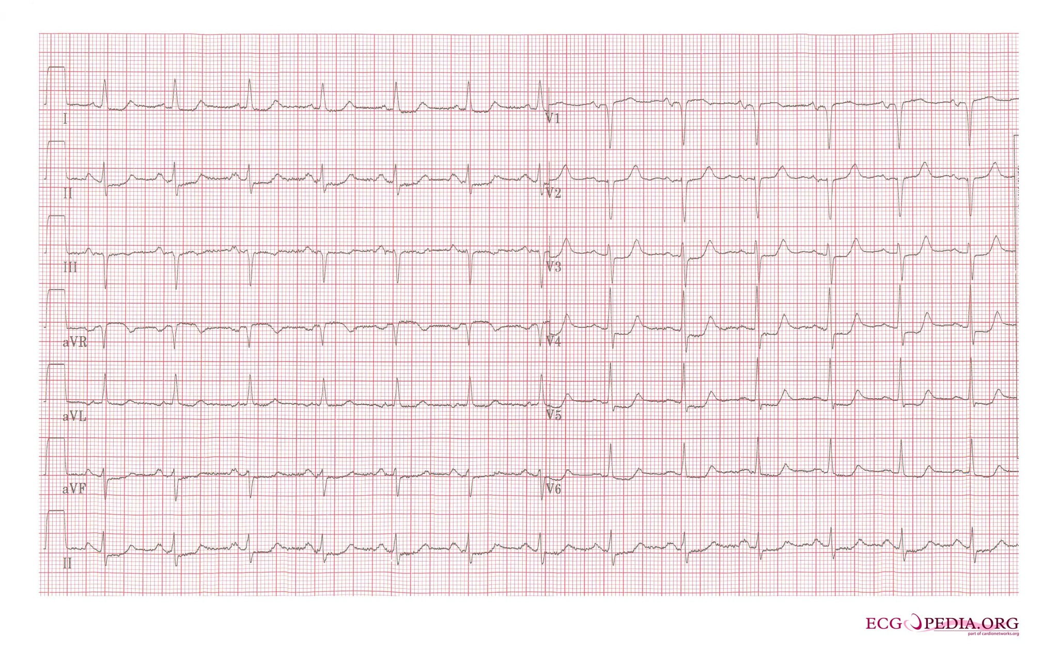
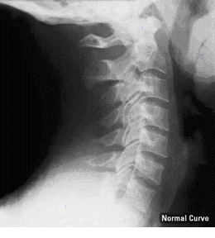

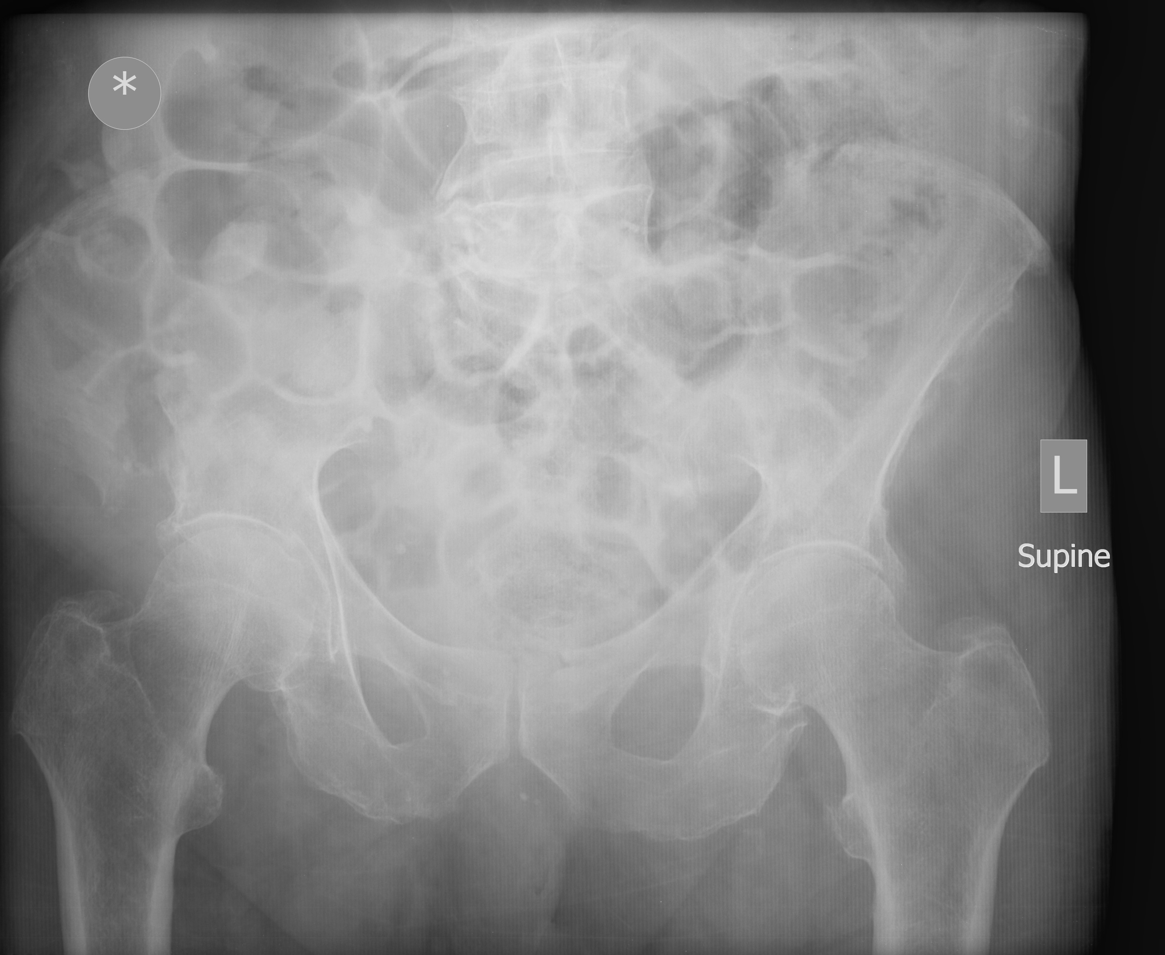

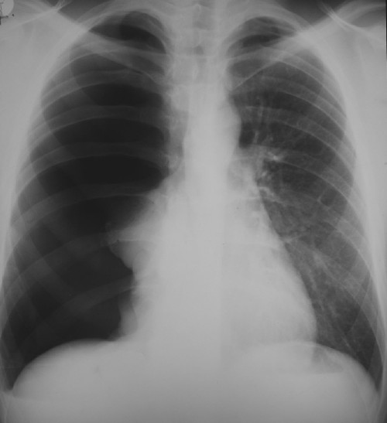

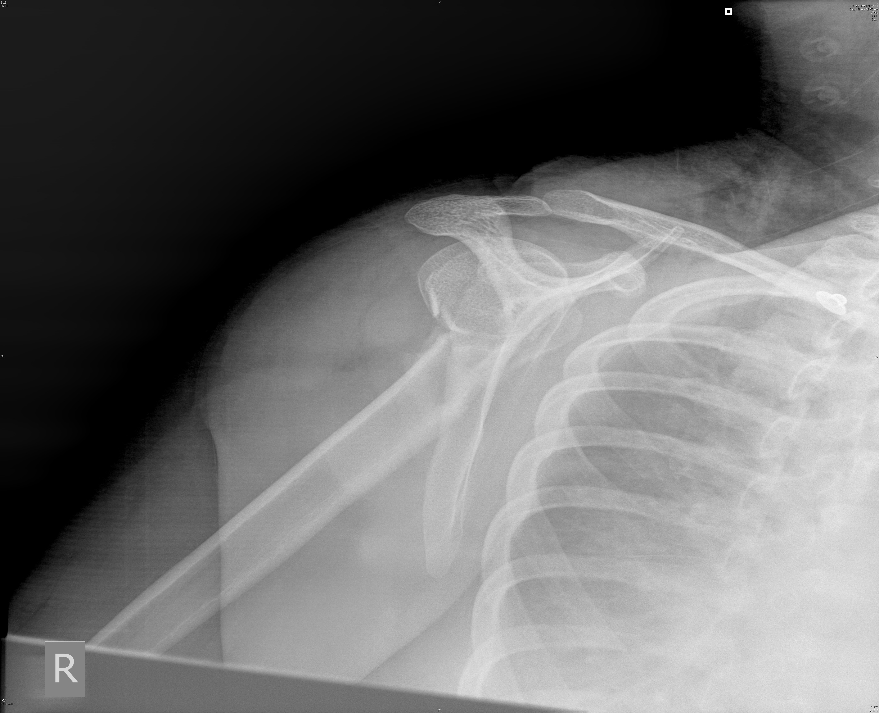

IMIST AMBO HANDOVER

I–Mohammed is a 72 year-old man, fell off a ladder
M - He fell from a ladder approx 3 m, whilst cleaning the gutters. He is unsure how he fell. He has pain in the right side of his body.
I - He has a graze on his head, bruising to the right side of his chest, hip, right arm and complaining of pain everywhere
S - HR 100, BP 120/78, GCS 15 but distressed, sats 95% on air, RR 24
T - 7.5mg of morphine iv, 10mg of metoclopramide. Not collared as he is non compliant.
A - NKDA
M – Ramipril and GTN spray
B - Hypertension and angina
O - Wife is on her way with the daughter and the son in law:

